CLASSIFIED
Copy _____ of _____
1st Battalion, 7th Cavalry Regiment
1st Armored Brigade Combat Team
1st Cavalry Division
130948CMAY18
FRAGMENTARY ORDER (FRAGO):
JUNIPER SPEAR
HBCT TO BATTALION OPERATIONS PLAN
REFERENCES:
- Area of Operation Overlay
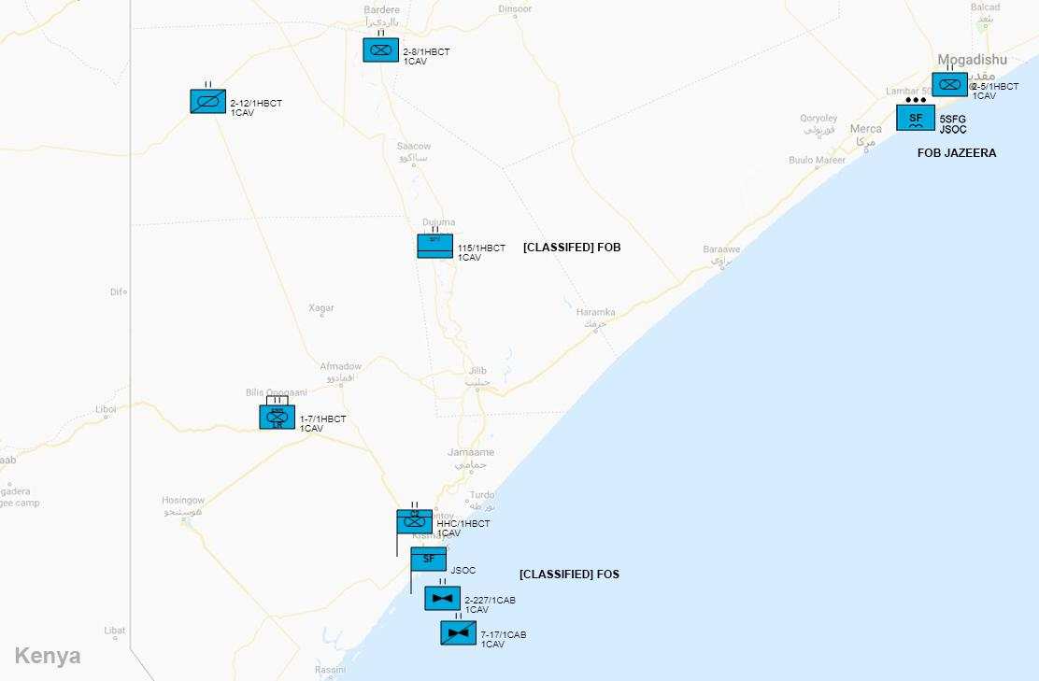
- Area of Interest Overlay - Bilis Qooqaani
TBA
- SITUATION.
Ahmad Umar (Umar), leader of Al-Shabaab in Somalia has been located in the town of Bilis Qooqani, just southwest of Afmadow, near the Kenyan border. 1-7 CAV is being immediately retasked to to Bilia Qooqani to surround and neutralize Umar before he reaches the Kenyan Border.
  - General. No change.
    - Assessment of the Conflict.
With the WMDs captured and neutralized, the last offensive objective in Operation Juniper Spear is to capture, or kill, Ahmad Umar (“Umar”). Umar has reached Al Shabaab occupied territory in south-western Somalia along the Kenyan border. The town of Bilis Qooqani is Al Shabaab controlled town, with no SNSF present. It is heavily fortified, however, Al Shabaab has not had adequate time to fully prepare for our arrival. To send a clear message to terrorists around the world, 1-7 CAV is to pursue, surround, and capture or kill, Umar.
    - Policy Goals
      - US/Multinational Policy Objectives. No change.
      - End State.
The desired end-state of this operation is to capture, or kill, Ahmad Umar.
    - Non-US National Strategic Decisions. No change.
    - Operational Limitations. No change.
  - Area of Concern
    - OA
The Operational Area (OA) is Somalia.
No change.
    - Area of Interest
The area of interest for phase two of Operation Juniper Spear is the town of Bilis Qooqani (“Qoqani”), Somalia.
Qoqani is a town in the Afmadow district of the Lower Juba (Jubbada Hoose) region of southern Somalia. The city is approximately 70 kilometers away from the Kenya-Somali border and has an estimated population of around 25,000.
People in this area depend on pond water, which is highly polluted, and malaria, which is common in this area, claims many lives every year, most of them women, children, and the elderly. The region is one of the most affected by the drought-induced humanitarian crises that has recently affected Southern Somalia. The nearest medical facility (though itself undeserved) is about 30 miles away from Qoqaani.
Weather in the region is estimated to have high temps of 37°, low temps of 23°, partly sunny, warm, and intermittent rain.
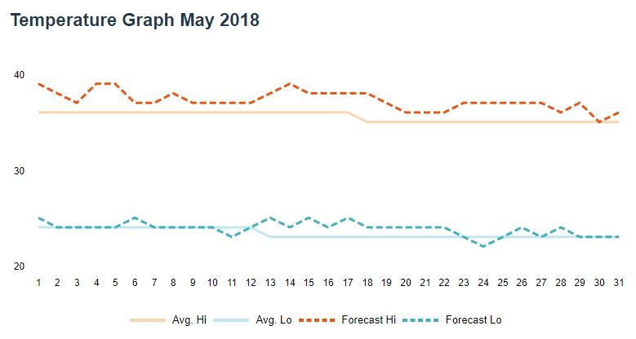
  - Deterrent Options.
No deterrent options are available at this time.
  - Risk
The primary risk to the CJTF-HOA, and population of the Horn of Africa generally, is the continued leadership of Ahmad Umar within Al Shabaab. To allow Umar to escape into Kenya will provide him leverage to continue leading Al Shabaab, as well as further embolden terrorists around the world.
  - Enemy Forces
The primary enemy force within the Area of Interest is Al Shabaab. See Annex B [Intelligence] for details.
No change.
The named leader of the group is Ahmad Umar.
    - Enemy Center of Gravity (COGs)
      - Strategic. No change.
      - Operational
The Enemy's operational COG is the center of Qoqani.
    - Enemy Critical Factors
      - Strategic
Qoqani is an Al Shabaab stronghold. There are likely thousands of Al Shabaab fighters in the city who are intimately familiar with the terrain.
      - Operational
Umar will be heavily fortified by large numbers of Al Shabaab fighters. They will be deeply entrenched. Al Shabaab groups will likely establish ambush and quick response sites throughout the city.
    - Enemy COAs
      - General
Umar is on the run, in an attempt to flee into Kenya. He has reached Al Shabaab held territory. If pursued, Umar will likely continue to run. Al Shabaab fighters will staunchly defend Umar, as well as due everything they can to slow down, and stop, his pursuit.
      - Enemy’s End State
No change.
      - Enemy’s Strategic Objectives
No change.
      - Enemy’s Operational Objectives
No change.
      - Enemy CONOPs
The enemy’s concept of operation is continue moving west towards the Kenyan border.
    - Enemy Logistics and Sustainment
No change.
    - Other Enemy Forces / Capabilities
No change.
    - Enemy Reserve Mobilization
No change.
  - Friendly Forces
    - No change.
    - Friendly COGs
      - Strategic
        - Camp Lemonnier, Djibouti (CJTF-HOA).
        - Headquarters and Headquarters Company (HHC) will be based at FOS [Classified] Kismayo, along with US-JSOC.
      - Operational
        - 1-7 CAV (CAB) [Enhanced Task Force] will be on the move southwest to Qoqani.
        - 2-5 CAV (CAB) - No change.
        - 2-8 CAV (CAB) - No change.
        - 2-12 CAV (ARS) will move southwest of 2-8 CAV’s position as a QRF for 1-7 CAV, if needed.
        - 115 BSB - No change.
        - 2-227 AVN (General Support) - No change.
        - 7-17 CAV (Attack Reconnaissance) - No change.
    - Friendly Critical Factors
      - Strategic
        - Keep Umar from escaping.
        - No change.
      - Operational
        - Time is of the essence. Surround Umar before he can escape into Kenya.
        - Avoid civilian casualties.
    - Multi-National Framework. No change.
    - Supporting Command and Agencies
      - No change.
  - Assumptions
    - Threat Warning / Timeline.
Qoqani is only 70 kilometers from the Kenyan border. Surround Qoqani and neutralize Umar immediately.
    - Pre-Positioning / Regional Access.
No change.
    - In-Place Forces.
No change.
    - Strategic Assumptions.
OPFOR will likely hold position, and utilize guerrilla style tactics in defense. OPFOR will likely be reinforced from the west (Kenya).
  - Legal Considerations
    - ROE. Strict ROE applies for contact with all civilians. Civilians may be armed. Engage only in self-defense, unless mission parameters dictate otherwise.
    - International Law (inc. Law of War). No change.
    - US law. No change.
    - HN and partner nation policies. No change.
    - Status of forces agreements. No change.
    - Other bilateral treaties and agreements. No change.
    - HN agreements to include HNS agreement. No change.
- MISSION
1-7 CAV is to move immediately from Afmadow to Qoqani, surround the city, then capture or kill Umar.
- EXECUTION
  - Initial Commander's Intent.
See mission.
  - Concept of Operations.
    - Phases.
      - Deployment. 1-7 CAV will deploy to Qoqani and establish a hasty Battalion Command Post.
      - Encirclement. 1-7 CAV will surround Qoqani and cut-off Umar’s escape routes.
      - Reconnaissance in Force. 1-7 CAV will reconnaissance in force in search of Umar’s location.
      - Breakthrough. 1-7 CAV will move to contact Umar’s location.
      - Exploitation. 1-7 CAV will neutralize Umar.
    - Primary Maneuver Elements. No change.
    - Fire Support. No change.
  - Tasks to Maneuver Units. No change.
  - Tasks to Combat Support Units. No change.
  - Coordinating Instructions.
    - HHC to establish hasty Battalion Command Post at Qoqani, Somalia.
    - All other coordinating tasks to be determined at the Task Unit level, via OPORD.
- SERVICE SUPPORT
  - General.
    - Sustainment operations will be coordinated with 115th BSB, Haramka.
    - Resupply will be coordinated with 115th BSB, Haramka.
    - Battalion CCP (Surgical Center) will be based at hasty BN CP (Qoqani).
    - Special medical instructions - None.
  - Materials and Services.
    - Supply: No change.
    - Transportation. No change.
    - Services. All services to be setup at Battalion Command Post.
    - Maintenance. No change.
  - Medical Evacuation.
    - No change.
  - Personnel.
    - Reinserts will be brought back to Battalion Command Post (Qoqani) from 115 BSB logistics hub via 2-227 AVN.
    - EPWs are to be detained, searched, and cleared of all weapons and equipment, then consolidate at BN CP for transport to FOS [Classified], Kismayo.
  - Miscellaneous. N/A.
- COMMAND AND SIGNAL
  - Command.
    - HHC 1ABCT is based out of FOB [Classified], Kismayo.
    - Battalion CP located at Qoqani.
    - Succession of Command.
      - Battalion Commander
      - Battalion Executive Officer
      - Battalion Sergeant Major
      - S3 Officer in Charge
    - Adjustments to the unit SOP. None.
  - Signal. No change.

ACKNOWLEDGE: COL A. Grgich
Commanding

Table X. List of Attachments and responsible staff officers
Annex | Responsible Officer | Included / Omitted
ANNEX A - TASK ORGANIZATION | S-3 | Omitted. See Section 3(c) of FRAGO.
ANNEX B - INTELLIGENCE | S-2 | Included
ANNEX C - OPERATIONS | S-3 | Omitted. TBD based on future missions.
ANNEX D - FIRES | Fire Support Officer | N/A
ANNEX E - PROTECTION | Chief of Protection | Omitted. Brigade echelon.
ANNEX F - SUSTAINMENT | S-4 | Omitted. Brigade echelon.
ANNEX G - ENGINEER | Engineer Officer | Omitted. TBD based on future missions.
ANNEX H - SIGNAL | S-6 | Omitted. Brigade echelon.
ANNEX I - Not Used
ANNEX J - PUBLIC AFFAIRS |  | Omitted. See Brigade Campaign Plan.
ANNEX K - CIVIL AFFAIRS OPERATIONS | S-9 | Omitted. See Brigade Campaign Plan.
ANNEX L - INFORMATION COLLECTION | S-3 | Omitted. See Section III.B.1(b) of FRAGO.
ANNEX M - ASSESSMENT | S-3 | Omitted. Brigade echelon.
ANNEX N - SPACE OPERATIONS | Space Operations Officer | Omitted. Brigade echelon.
ANNEX O - Not Used
ANNEX P - HOST NATION SUPPORT | S-4 | Omitted. Brigade echelon.
ANNEX Q - KNOWLEDGE MANAGEMENT | Knowledge Management Officer | Omitted. Brigade echelon.
ANNEX R - REPORTS | S-3, S-5, and Knowledge Management Officer | Included.
ANNEX S - SPECIAL TECHNICAL OPERATIONS | Special Technical Operations Officer | Omitted. Brigade echelon.
ANNEX T - Spare
ANNEX U - INSPECTOR GENERAL | Inspector General | Omitted. Brigade echelon.
ANNEX V - INTERAGENCY COORDINATION | S-3 and S-9 | Omitted. Brigade echelon.
ANNEX W - OPERATIONAL CONTRACT SUPPORT | S-4 | Omitted. Brigade echelon.
ANNEX X - Spare
ANNEX Y - Spare
ANNEX Z - DISTRIBUTION | S-3 | Omitted. Brigade echelon.

ANNEX B - INTELLIGENCE
No. _____ of _____
1st Battalion, 7th Cavalry Regiment
1st Armored Brigade Combat Team
1st Cavalry Division
130948CMAY18
ANNEX B (INTELLIGENCE) TO
CAMPAIGN PLAN/ORDER
REFERENCES:
Overlay 1 - See FRAGO.
Time Zone Used Throughout the Plan/Order: East Africa Time Zone (UTC +03:00)
Situation. See FRAGO.
Area of Interest. See FRAGO.
Area of Operations. See FRAGO.
- Terrain. See Task Unit OPORD.
- Weather. See Task Unit OPORD.
- Enemy Forces (Locations / Composition / Disposition). See overlays.
- Friendly Forces. US-JSOC - Provide intelligence through UAV reconnaissance from FOS [Classified], Kismayo, SNSF intelligence gathering, and HUMINT.
- Interagency, Intergovernmental, and Nongovernmental Organizations. None present.
- Civil Considerations. Civilians remain in Qoqani. Many are sympathetic to Al Shabaab. Many are unaware and simply living.
- Attachments and Detachments. None.
- Assumptions.
  - OPFOR is heavily entrenched and fortified.
  - OPFOR will likely use minefields, IEDs, VIEDs, and suicide bombers to prevent movement towards their encampments.
  - OPFOR may use civilians as human shields.
  - Umar is hiding somewhere in the city.
ACKNOWLEDGE: SGT K. Schmidtg
S-2 NCOIC
 | MOST WANTED  TERRORIST
Ahmad Umar
Ahmed Omar (Somali: Axmed Cumar, Arabic: أحمد عمر‎), also known as Ahmed Diriye and Abu Ubaidah, is the Emir of the Somalia-based Islamist group Al-Shabaab. He was listed by the US State Department as a Specially Designated Global Terrorist in April 2015.

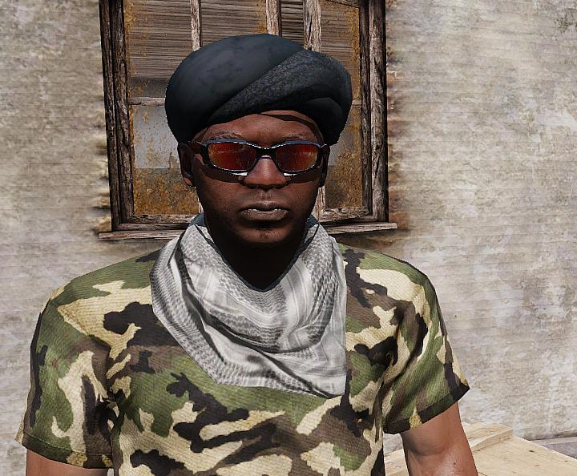

Aliases: Axmed Cumar, Ahmed Diriye, and Abu Ubaidah
Dates of Birth Used: Unknown | Place of Birth: Somalia
Hair: Black | Eyes: Brown
Height: 5’11” | Weight: 195 lbs.
Build: Thin | Complexion: Dark
Sex: Male | Citizenship: Somalia
Languages: English, Unknown | Scars and Marks: Unknown.

REWARD
The rewards For Justice Program, United States Department of State, is offering $6,000,000 for information leading directly to the apprehension or conviction of Ahmad Umar.
REMARKS
He is believed to be in his forties and is a member of the Bajimaal section of the Dir clan from the Kismayo region of Somalia.
SHOULD BE CONSIDERED ARMED AND DANGEROUS
If you have any information concerning this person, please contact your local FBI office or the nearest American Embassy or Consulate.

ANNEX R - REPORTS
No. _____ of _____
1st Battalion, 7th Cavalry Regiment
1st Armored Brigade Combat Team
1st Cavalry Division
130948CMAY18
ANNEX R (REPORTS) TO
CAMPAIGN PLAN/ORDER
REFERENCES:
Overlay 1 - See WARNO.
Time Zone Used Throughout the Plan/Order: East Africa Time Zone (UTC +03:00)
Reports.
- RECONNAISSANCE
  - ROUTE REPORT [ROUTEREP]
Use to report results of route reconnaissance. Reference: FM 5-34, FM 17-95, and FM 17-98.
  - SURVEILLANCE AND RECONNAISSANCE PLAN REPORT [SURRECONREP]
Use to report reconnaissance and surveillance plans. Reference: FM 34-2-1.
  - RECONNAISSANCE NICKNAME REPORT [RECON 1]
Use to report additions, changes, or deletions of operation order numbers and associated nicknames for reconnaissance. Reference: FM 34-2-1and FM 101-5.
  - RECONNAISSANCE TRACK REPORT [RECON 2]
Use (1) to submit proposed reconnaissance tracks for mission approval and (2) to modify or delete existing active reconnaissance tracks. Reference: FM 34-2-1 and FM 101-5.
  - RECONNAISSANCE SCHEDULING REPORT [RECON 3]
Use (1) to provide selected and specific data on proposed reconnaissance mission schedules, (2) to make changes to approved schedules, and (3) to inform of CINC/unit intention to fly specific reconnaissance missions. Reference: FM 34-2-1 and FM 101-5.
  - RECONNAISSANCE FOLLOWING REPORT [RECON 4]
Use to provide specific information pertaining to a reconnaissance mission flight. Reference: FM 34-2-1, FM 100-103, and FM 101-5.
  - RECONNAISSANCE EXPLOITATION REPORT [RECCEXREP]
Use to provide an abbreviated imagery interpretation report in a tactical situation

- MISSION
  - WAR CRIME REPORTABLE INCIDENT REPORT [WCRIR]
Use to convey flash traffic to the commander relating to a possible, suspected, or alleged violation of the law of war discovered within the command.
  - PATROL REPORT [PATROLREP]
Use to report information and combat actions obtained on mounted and dismounted patrols. Reference: FM 17-98, FM 17-95, FM 7-92, and FM 34-3.
  - EXPLOSIVE ORDNANCE DISPOSAL SUPPORT [EODSPT]
Use (1) to request explosive ordinance disposal (EOD) support, (2) to report the results of an EOD mission, or (3) to request EOD support to protect designated very important persons. Reference: FM 9-15.
  - MEDICAL SITREP [MEDSITREP]
Use to convey a quick, consolidated medical status report as a snapshot rather than a full report. Reference: FM 8-10-3.
  - SPOT REPORT [SPOTREP]
Use to send information to provide timely intelligence or status regarding events that could have an immediate and significant effect on current planning and operations. Reference: FM 17-15, FM 17-98, and FM 7-7.
  - BATTLE DAMAGE ASSESSMENT REPORT [BDAREP]
Use to provide a timely and accurate estimate of damage resulting from the application of military force, either lethal or non-lethal, against a predetermined objective. Reference: FM 9-43-1.
  - SAEDA REPORT [SAEDAREP]
Use to provide notification of a Subversion and Espionage Directed Against the Army (SAEDA) incident. Reference: FM 34-60 and AR 310-50.
  - PRELIMINARY TECHNICAL REPORT [PRETECHREP]
Use to disseminate initial technical information on captured or acquired foreign material and ordnance. Reference: FM 34-54 and FM 34-60.
  - SEARCH AND RESCUE INCIDENT REPORT [SARIR]
Use to report any situation that may require a search and rescue effort. Reference: FM 1-108 and FM 1-513.
  - SURVIVABILITY REPORT [SURREP]
Use to report the completion of survivability tasks. Survivability tasks include digging, revetment, camouflage, and hardening of buildings. Reference: FM 5-34, FM 5-100, and FM 5-102.
  - ENEMY/PRISONER OF WAR REPORT [EPOW]
Use to convey status and disposition of unit’s EPWs. Send IAW unit SOPs. Reference: FM 19-40.
  - LACE REPORT [LACE]
Used to report status after contact with the enemy.
  - CLOSE AIR SUPPORT SUMMARY [CASSUM]
Use to provide timely reports of close, air-support missions and other information obtained during post-flight aircrew debriefing. Reference: FM 6-71.
  - ACCIDENT REPORT/SERIOUS INCIDENT REPORT [SIR]
Use to convey flash traffic to the commander and command post relating to an accident or serious incident within the command. Use FLASH precedence on CMD nets. For all other stipulations and instructions refer to AR 190-40 (SIR) and AR 385-40 (Accident Report)
  - NBC SITUATION REPORT [NBCSITREP]
Use to report current NBC situation and chemical units’ activity. Send on a scheduled time line IAW unit SOPs, such as 0500, 1100, 1700, and 2300 daily. This is considered routine and is a normal report not indicated in NBC 1 through NBC 6 reports. Reference: FM 3-7.
  - DETAINED CIVILIAN PERSONNEL REPORT [DETAINCIVREP]
Use to provide commander of incidents where the unit has detained civilian personnel. Send IAW unit SOPs. Reference: FM 19-40.
  - ENEMY/FRIENDLY/UNIT MINEFIELD/OBSTACLE REPORT [MINOBREP]
Use to report all obstacles on the battlefield after developing a report. Disseminate information and report to all command posts and units in the area of operation as soon as possible. Reference: FM 90-13-1, FM 20-32, and FM 5-34.
  - AIR SUPPORT REQUEST [AIRSUPREQ]
Use to request preplanned and immediate close-air support, interdiction, reconnaissance, surveillance, escort, helicopter airlift, and other aircraft missions. For expedient hard copy or voice request use DD Form 1972 (Revised) 15 NOV 1994 (see Figure A020) or Sample TACAIR Briefing Form (see Figure A015).
- CAMPAIGN
  - CLOSURE REPORT [CLOSEREP]
Use to inform commander of status of movement and capability of the unit to conduct future operations. Submit upon completion of movement as directed by commander. Reference: FM 71-2 and FM 71-3.
  - OPERATION REPORT [OPREP]
Use to report operational situations, problems, recommended or intended courses of action, and other items not reported elsewhere. Send as determined by higher headquarters or by necessity of subordinate headquarters. Reference: FM 100-15, FM 71-100, and FM 101-5.
  - SLANT REPORT [SLANTREP]
Use to give the commander accurate and routine information regarding status of critical personnel and equipment necessary for the unit’s operation success. Submit when necessary or as directed. The commander designates the information to report during planning or by unit SOPs. Reference: FM 71-2 and FM 71-3.
  - RULES OF ENGAGEMENT AUTHORIZATION [ROEAUTH]
Use to authorize or refuse the implementation of specific rules of engagement. Reference: FM 101-5.
  - REQUEST FOR INFORMATION [RFI]
Use to request information from requesting unit’s command post or other units. Reference: FM 101-5.
  - FRAGMENTARY ORDER [FRAGO]
Use to send timely changes of existing orders to subordinate and supporting commanders while providing notification to higher and adjacent commands. Send FLASH precedence O&I or CMD IAW unit SOPs. Reference: FM 101-5.
  - CLASS IV BULK BARRIER MATERIALS REQUEST [BLKIVREQ]
Use to report a periodic update, forecast, or formal request of Class IV barrier materials a unit requires. Reference: FM 5-102, FM 20-32, and FM 90-7.
  - PERSONNEL STATUS REPORT [PERSTAT]
Use to report the status of the unit’s personnel. Reference: FM 12-6.
  - TRANSPORTATION SUPPORT REQUEST [TRANSSPTREQ]
Use to request transportation support other than airlift support. Reference: FM 701-58.
  - MAINTENANCE SUPPORT REQUEST [MAINTSPTREQ]
Use to request maintenance support. Reference: FM 9-43-1.
  - AVIATION (ARMY ROTARY WING) MISSION/SUPPORT REQUEST [AVIAREQ]
Use to request Army aviation units for support. Send from subordinate units to division/corps aviation cell at the main command post. Reference: FM 1-100 and FM 1-114.
  - OPERATION ORDER [ORDER]
Use to transmit the standard five-paragraph operation order (OPORD) and operation plan (OPLAN) that provide plans, instructions, and directives to subordinate and supporting military organizations. Reference: FM 101-5, FM 71-100, and FM 100-15.
  - UNIT SITUATION REPORT [UNITSITREP]
Use to inform commanders of operational plans, unit readiness, and operational situations or summaries. Reference: FM 100-15, FM 71-100, FM 71-3, and FM 71-2.
  - OPERATIONS PLAN CHANGE [PLANORDCHG]
Use to update or change existing operations plans. (Note: Use FRAGO to change OPORD.) Reference: FM 100-15, FM 71-100, and FM 101-5.
  - SEARCH AND RESCUE (SAR) REQUEST [SARREQ]
Use to request forces to participate in a search and rescue (SAR) mission. Reference: FM 1-108 and FM 1-513.
  - REQUEST CONFIRMATION [REQCONF]
Use (1) to inform the requesting command, tasking authority, and tasked units of actions being taken and (2) to provide additional information about the missions. Use for both preplanned and immediate air-tasking cycles. Reference: FM 100-103 and FM 1-100.
  - OPERATIONS SUMMARY [OPSUM]
Use to provide a commander’s summary of significant operations to the next higher commander. Reference: FM 100-15, FM 71-100, and FM 101-5.
  - COMMANDER’S SITUATION REPORT [SITREP]
Use to keep the commander’s higher and lower staff updated and advised on the reporting commander’s critical situation. Reference: FM 100-15, FM 71-3, and FM 71-2.
  - ROAD CLEARANCE REQUEST [ROADCLRREQ]
Use (1) to request road clearance and movement authority for the movement of outsized or overweight vehicles or (2) for the movement of convoys over a controlled or restricted road network. Reference: FM 100-15, FM 71-100, and FM 701-58.
  - WARNING ORDER [WARNORD]
Use to convey a preliminary notice of an impending order or action. Reference: FM 101-5-1 and FM 101-5.

ACKNOWLEDGE: 1LT J. Argus
S-3 OIC

